**The Ark Documentation.**

**Data Dictionary Upload function.**

Log in and select your study by clicking the hyperlink corresponding to the name of your study.

Once you have chosen your study we will be able to adjust study details or select modules and functions available in that study (for which you have privileges).

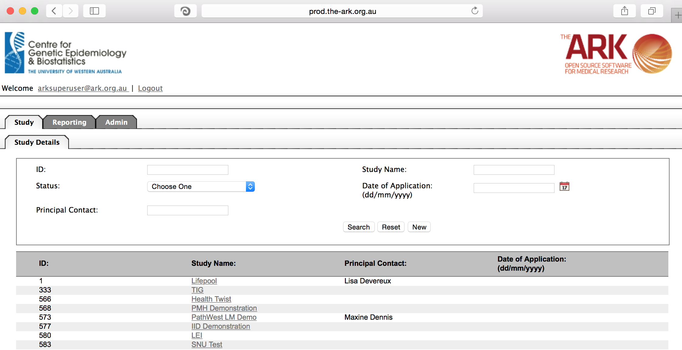

Alternatively if you have a very long list of studies under your management you may use the search pallette/panel at the top of the page. You can search/filter by id, name, principal contact, status of the study or date of application. Once you have added your filtering criteria, click the search button;

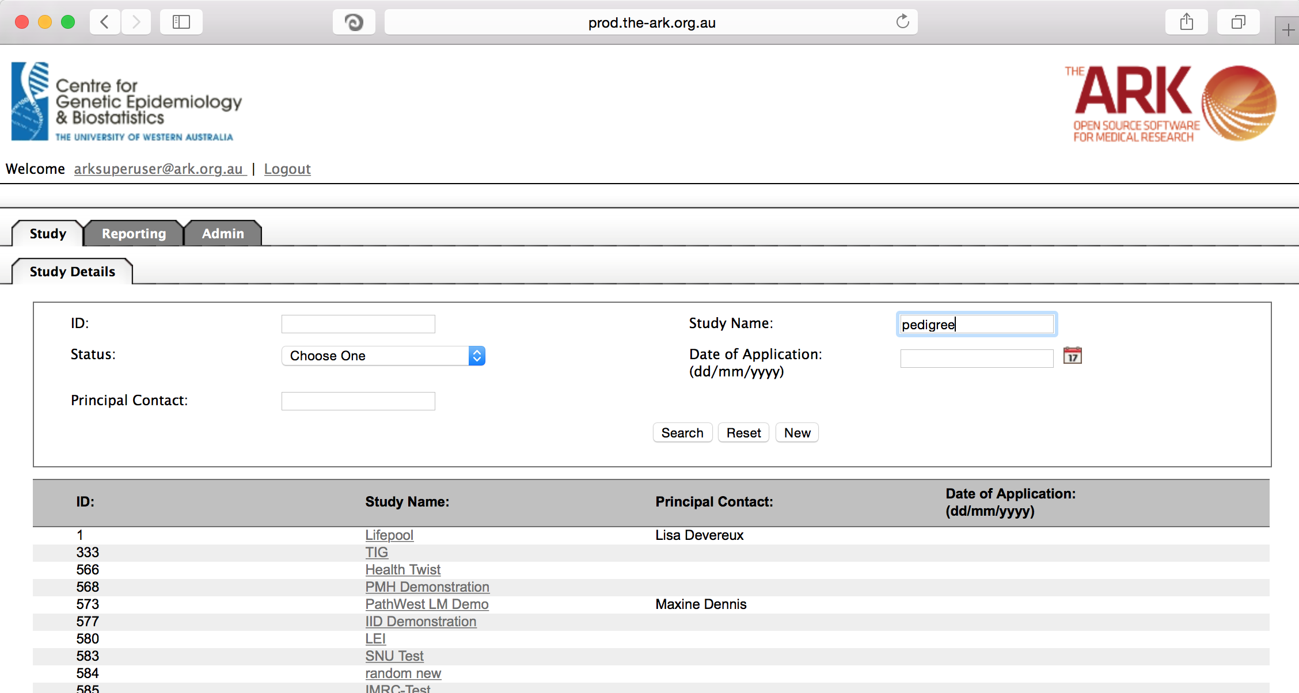

As you can see the filter has helped us find our chosen study and we can click the hyperlinked study name as discussed before;

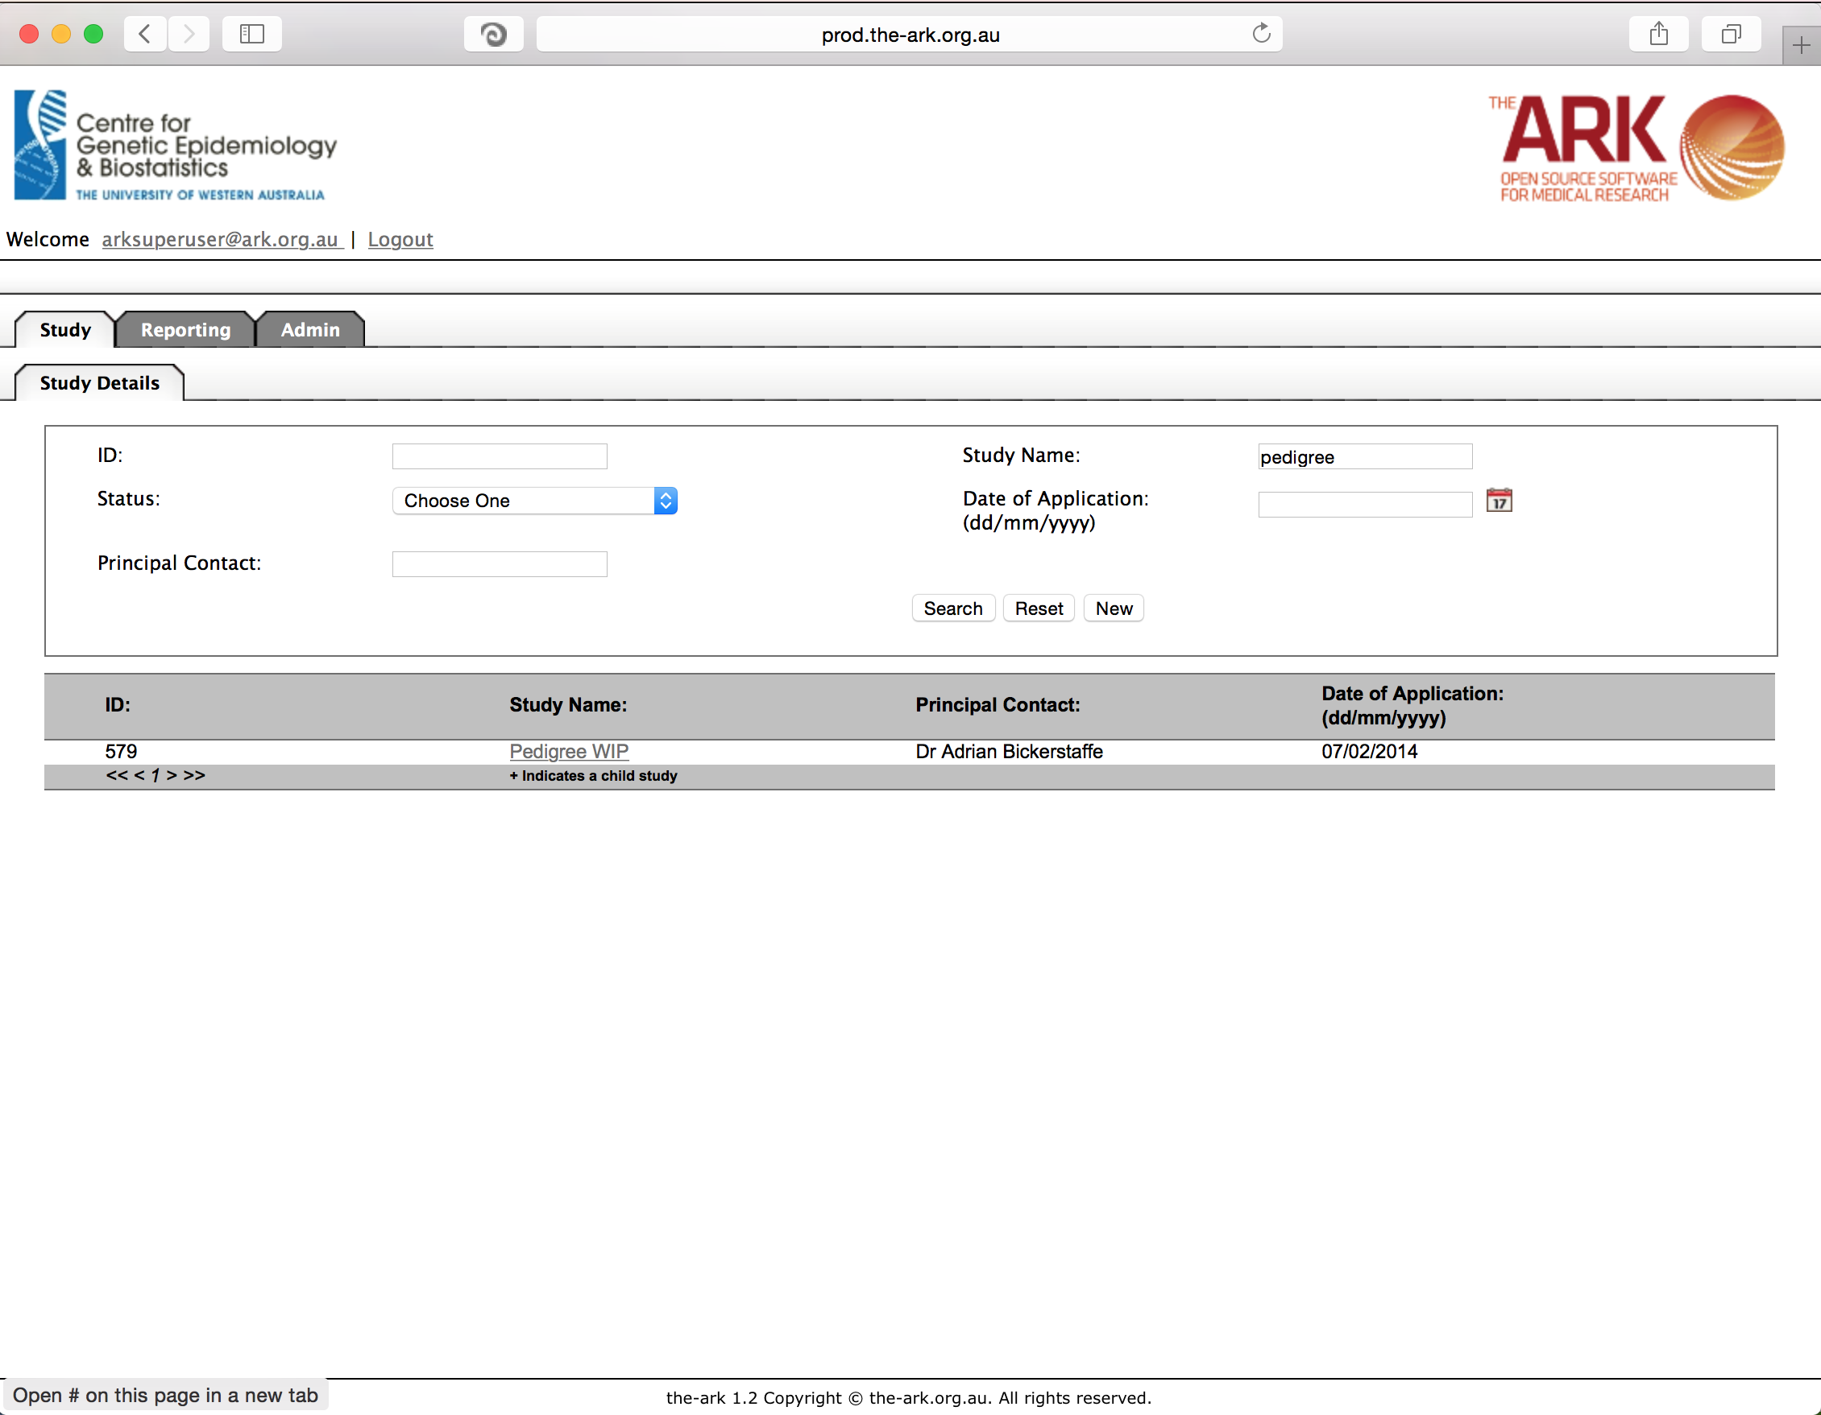

Once you have chosen your study we will be able to adjust study details or select modules and functions available in that study (for which you have privileges). The module we wish to select is Data Sets – then the function “Data Dictionary Upload”.

The data dictionary is the list of longitudinal fields you have to choose from for longitudinal data. Some like to consider this phenotypic data fields, and some have referred to the collections of these fields as datasets or questionnaires. We basically have fields, which can be reused and sets of fields which can be reused and re-run over time (ie; longitudinal data).

From our previous work, the example study below has fields based on systolic and diastolic blood pressure and a few other poorly named fields. These could be used in multiple collections of questions that will be repeated over time. If we want a convenient way to add many more fields at once, we can upload a CSV file containing the information about the fields rather than manually enter a field per page as we did in the Data Dictionary documentation.

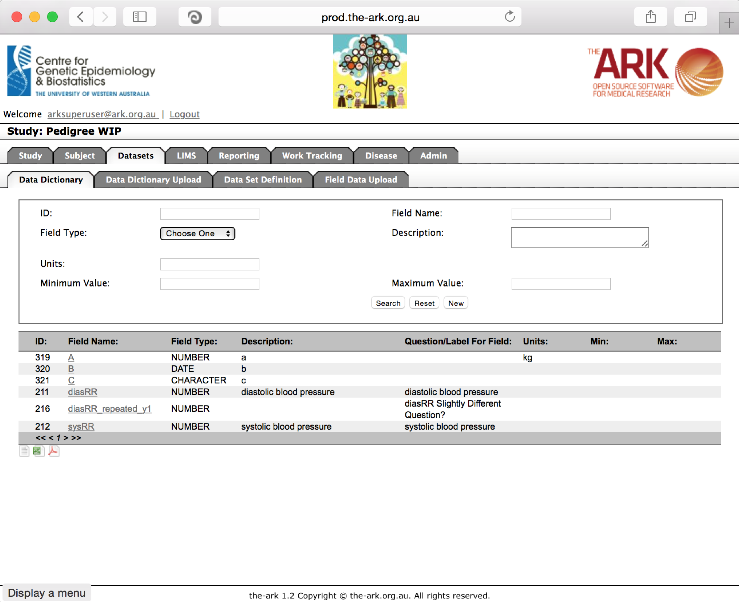

We will now add a 8th, 9th and 10th field Via an upload all at once.

After clicking Data Dictionary Upload, the following will appear, containing previous uploads for that study (with their results, completion status, the uploaded file itself and a report). A Download Template button also exists which will download the template of the data you need to upload;

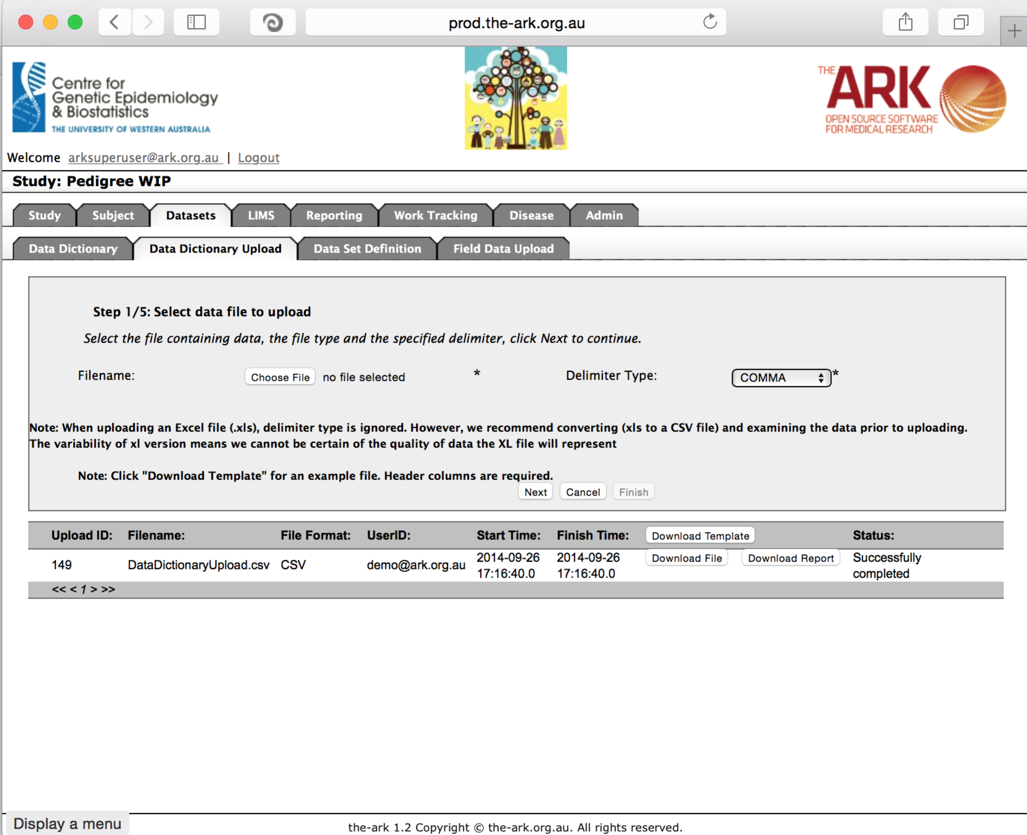

As described in the Data Dictionary documentation, some fields are not so self-explanatory and I will explain those below. The ID field is a system based uneditable field. Field Type can currently only be a number, text, or date. Number fields can have min/max values, and these limits will be strictly enforced on upload of data. A default value will be filled in if empty values are uploaded on a data set upload.

One field that confused some people is the encoded value field. This is described further in the custom field uploader documents. But basically, the idea is (for convenience or to enable data migrations/uploads from another system) you can upload shorthand values like 0 for no, 1 for yes by setting up encoded values as follows “0=no;1=yes;” (minus the quotes).

Utilizing the template, I have then added the following to a .CSV file.

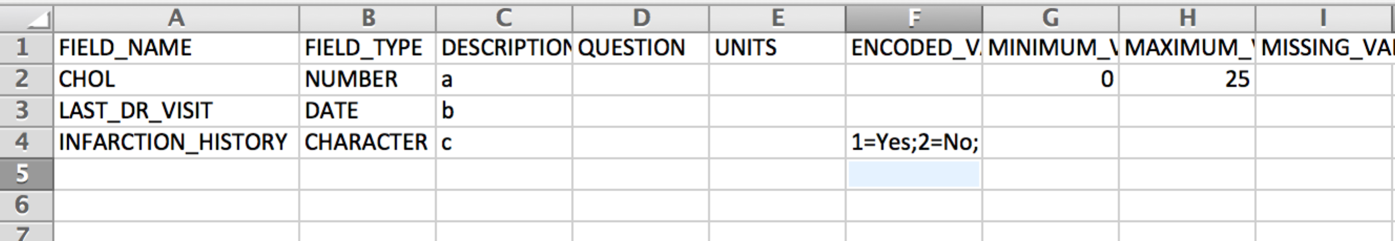

Once you have added the data you wish in a similar manner, then click save and name the file something logical which will be easy to remember and look back at;

Click the Choose File button, then select the CSV document you saved in the previous step. It is safest to always use the COMMA delimiter (CSV) in the Delimiter Type option.

Then click the Next button;

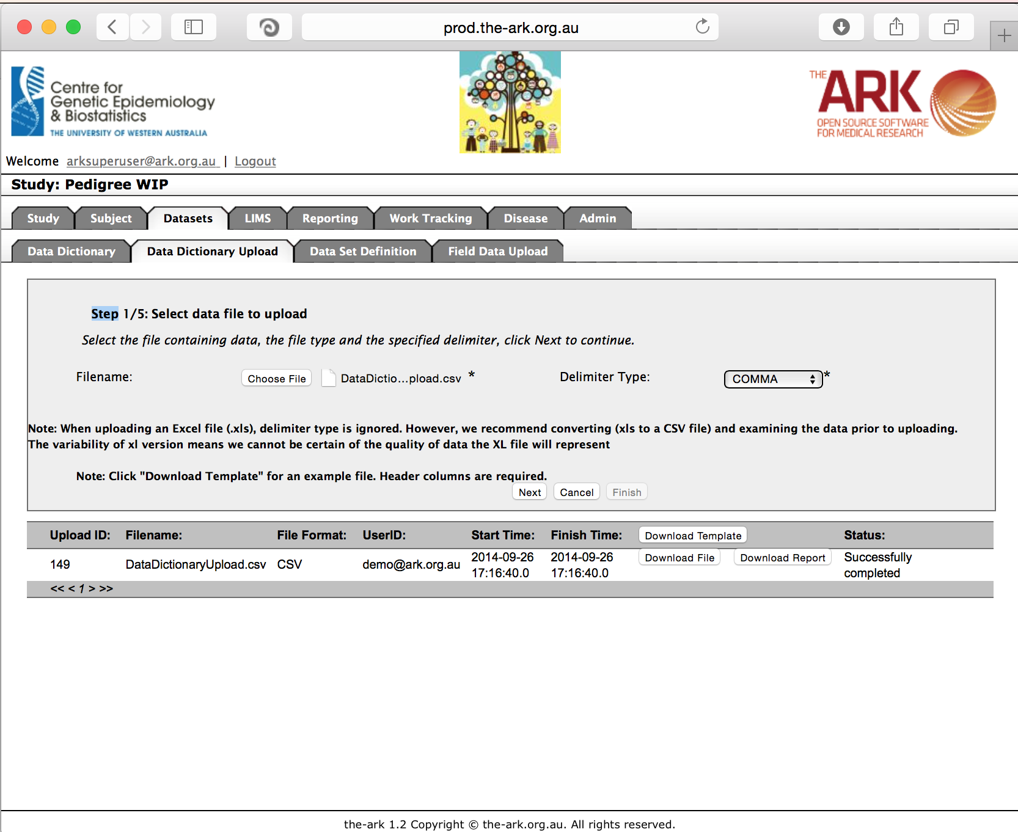

If you have no error messages your data will display as below. If you do have error messages, they will describe what is necessary to fix, and then you must go back to step one after having fixed your CSV file. If you work from the template, you will typically be just fine. If you have no errors and your code has been parsed as expected, click “Next”.

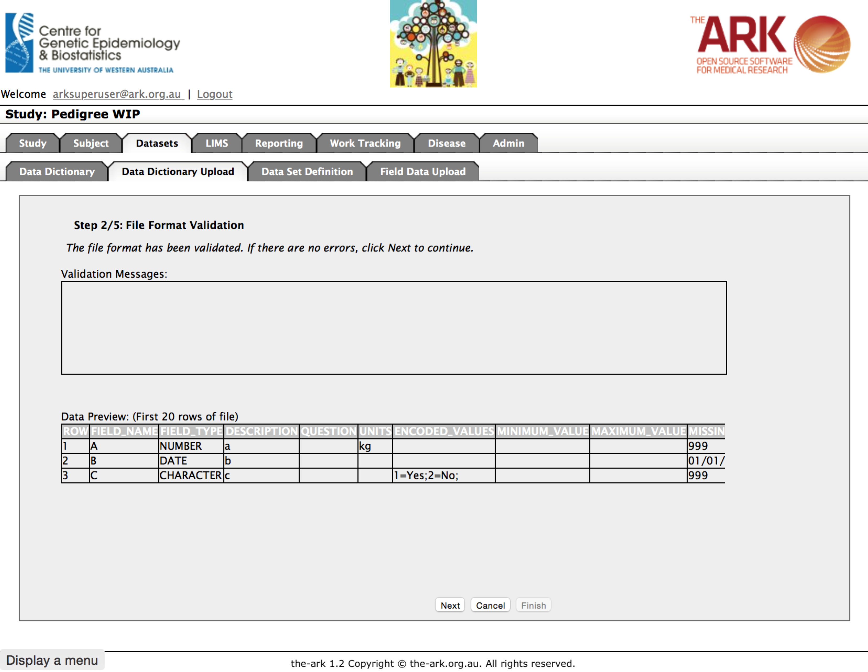

At this point data itself is validated, in this instance I didn’t Save my CSV correctly and so it had told me I will be updating existing fields! If I had intended to do this, I simply click the “update existing rows” checkbox and it will update those fields after clicking next.

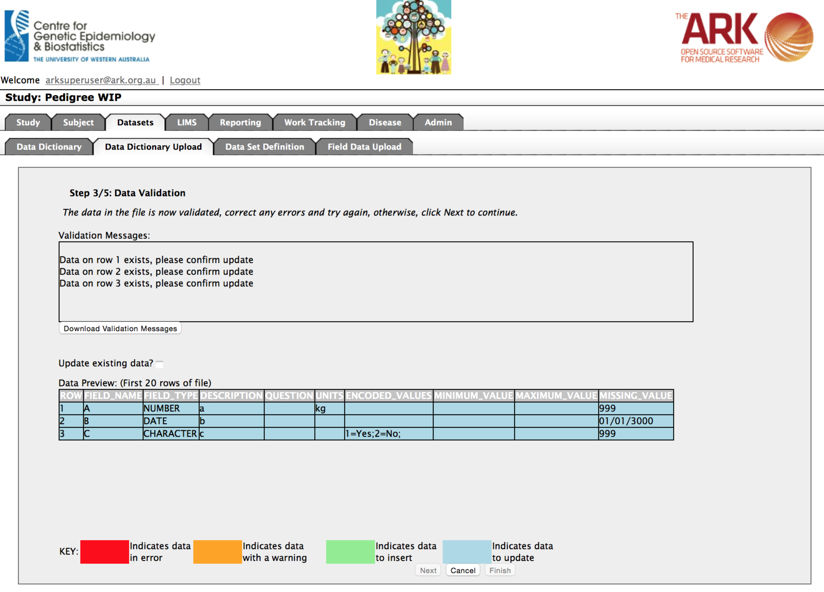

However that wasn’t my intention so I corrected the file, did step 1,2 all over again. Now at this point, If you have no error messages your data will display as below (all the green looks good, the data is what I expected, I can continue). If you do have error messages, they will describe what is necessary to fix (like on the previous page), and then you must go back to step one after having fixed your CSV file. If you work from the template, you will typically be just fine. If you have no errors and your code has been parsed as expected, click “Next”.

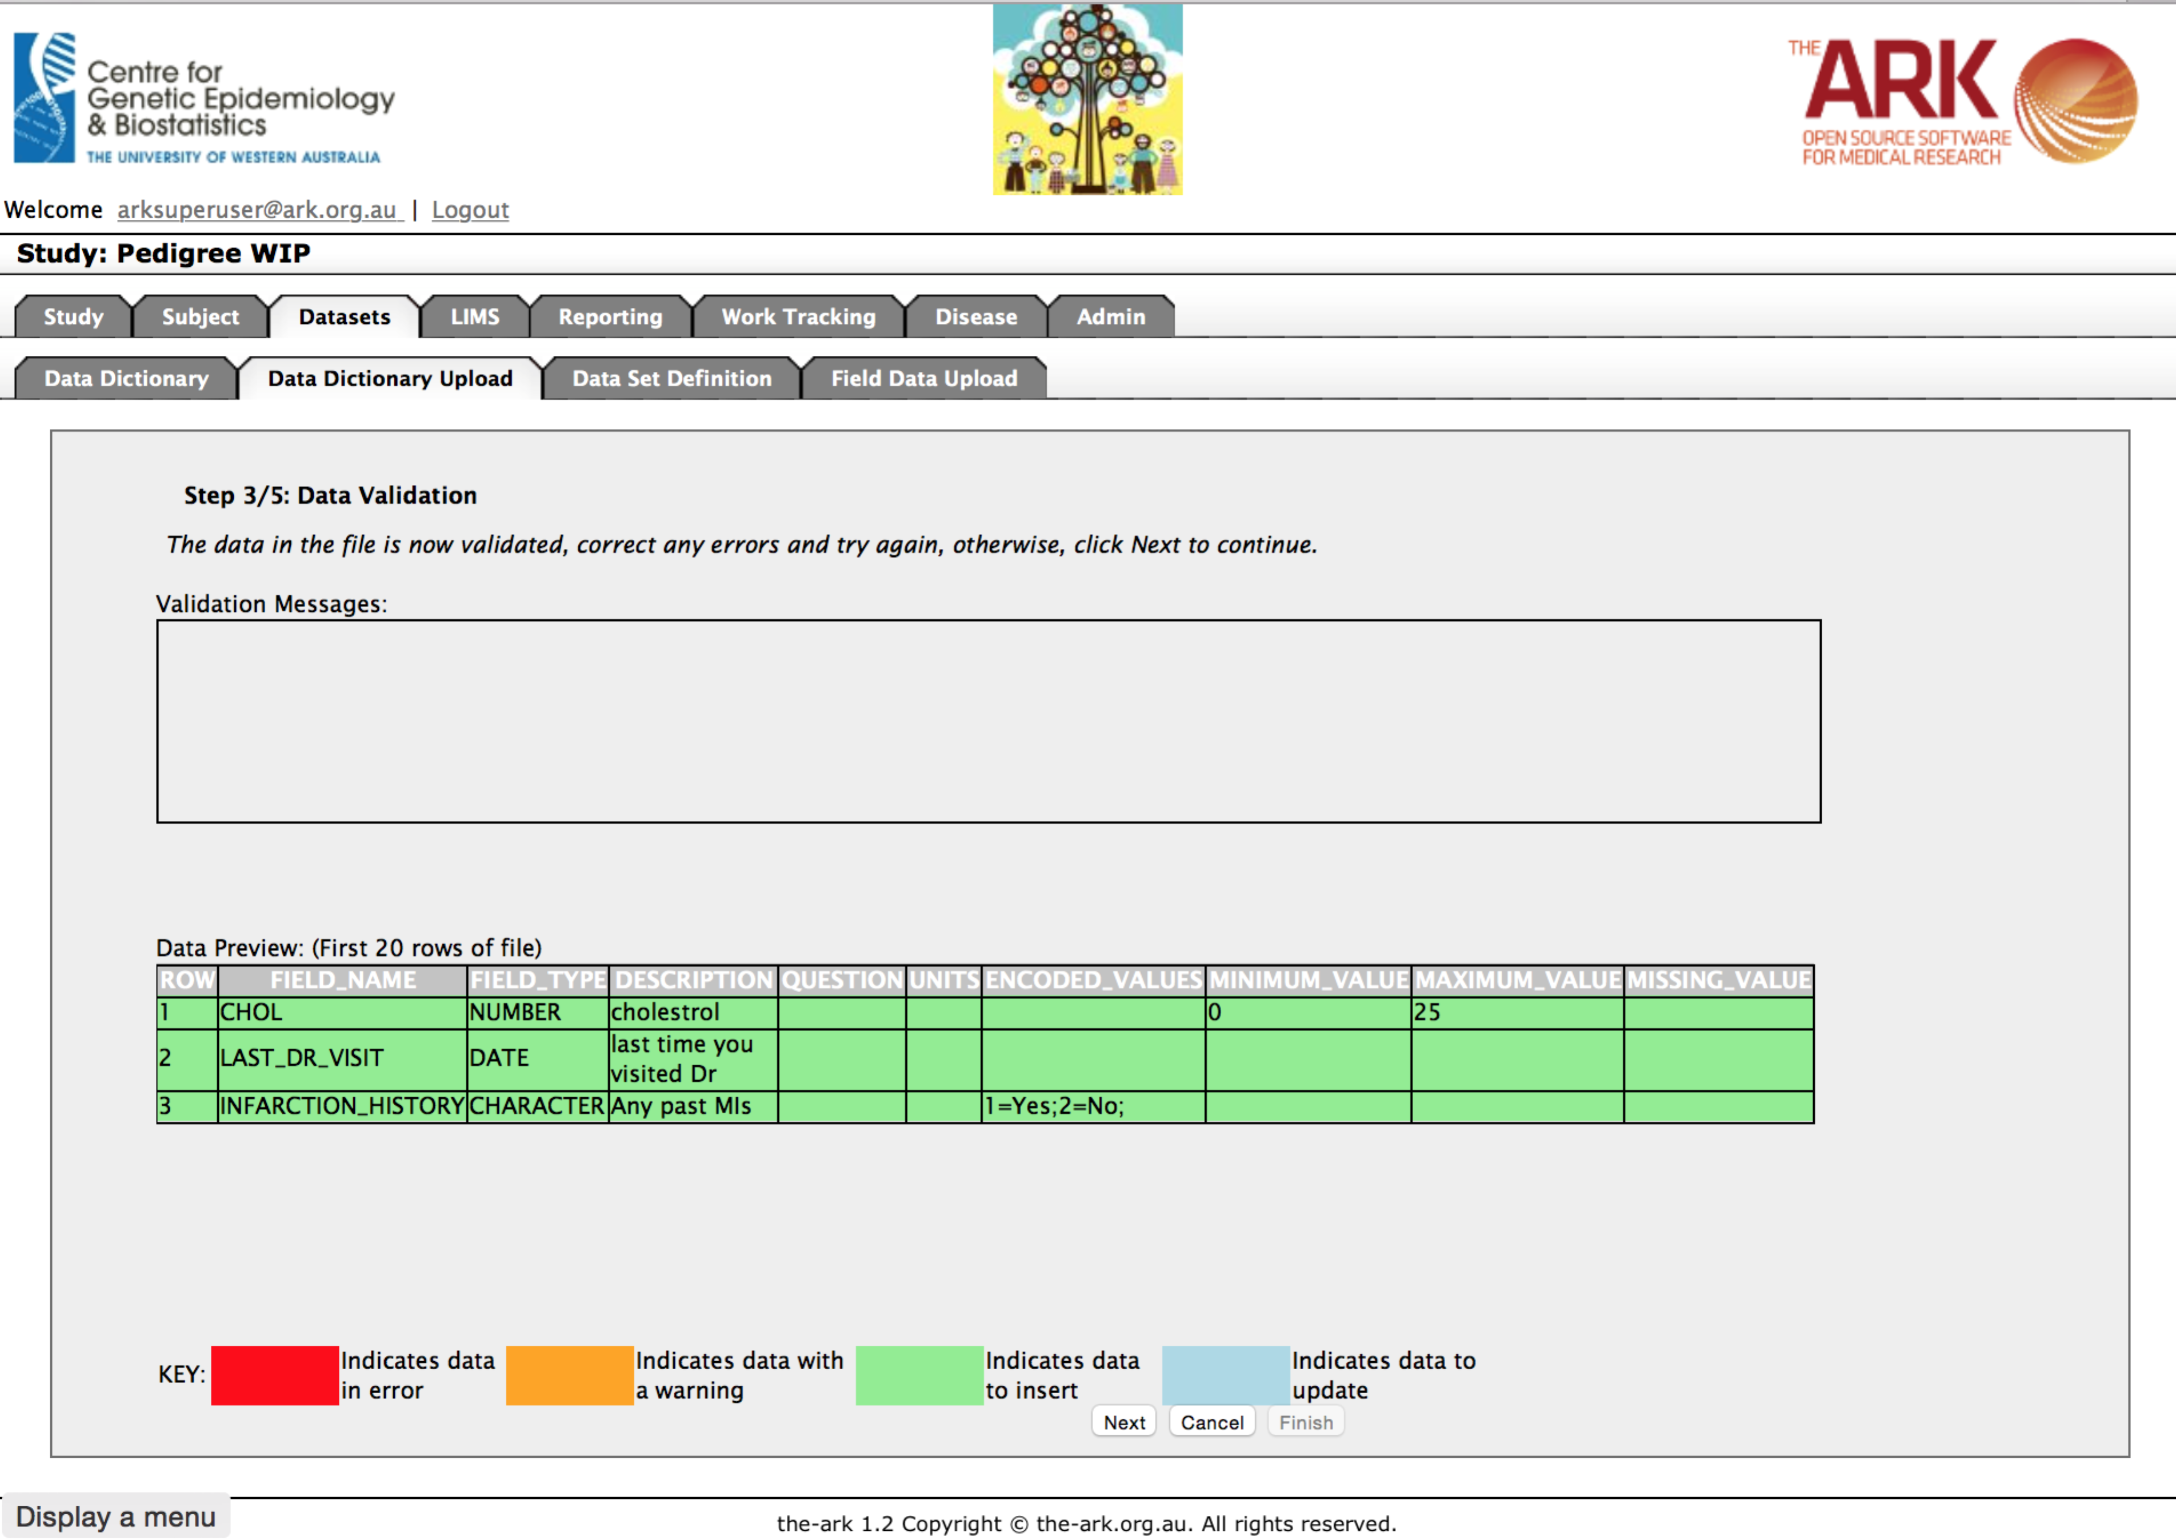

If that all worked fine, you get the following step to confirm the changes. Click next.

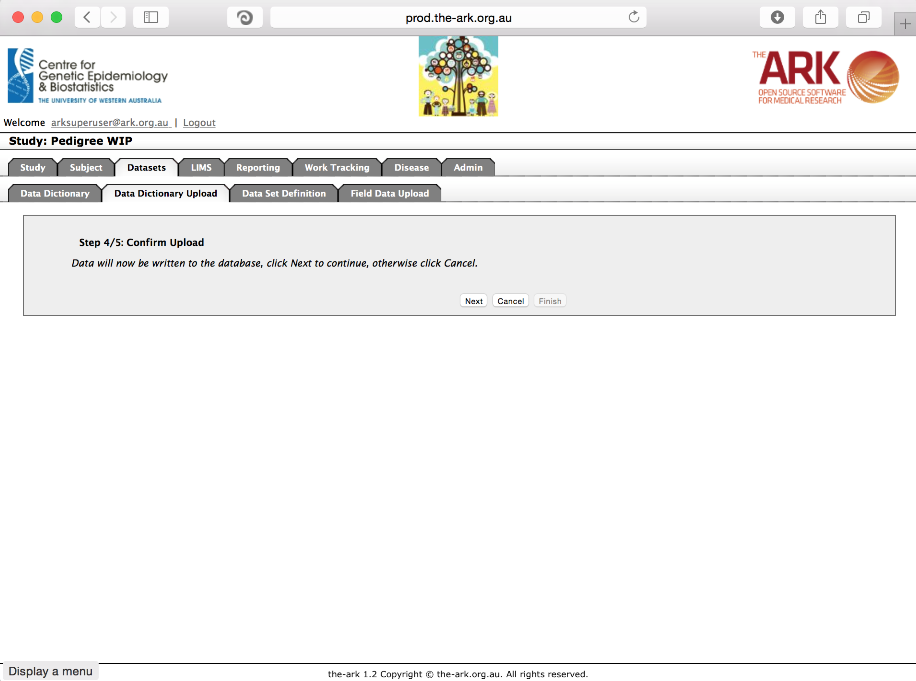

You have now confirmed changes, step 5 should show up which is just a confirmation from The Ark that your upload is SUMBITTED. That does not actually mean it is completed as the message hints (since fixed in our code base). Rather, a background job has been submitted. It will be complete when you come back to Data Dictionary upload later and see a status of “Successfully Completed”

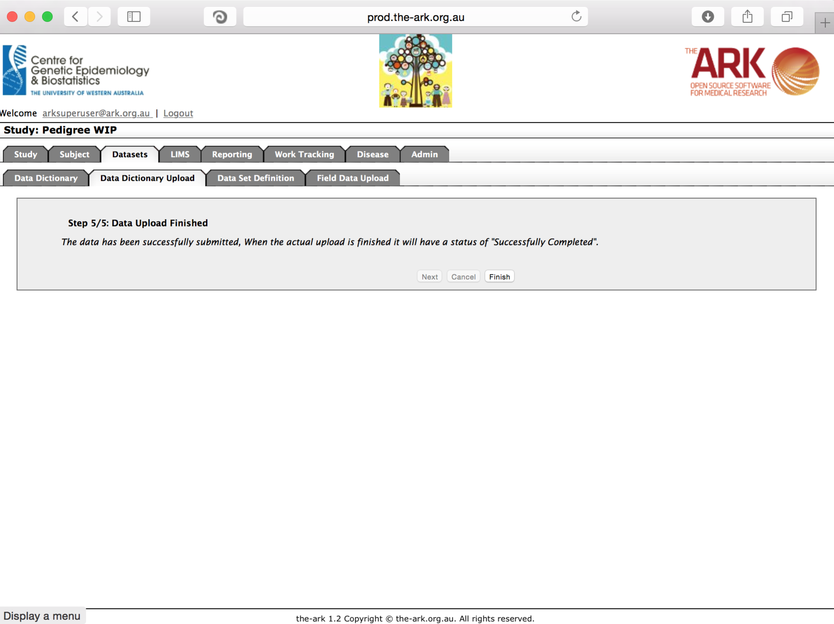

See the first row is the upload we just did, the status says successfully completed. You can check the report to see if results were as expected

